

DATA STRUCTURES & ALGORITHMS
23CSE203
LAB MANUAL
Submitted By
Name | Pardhiv Sai B
Roll No. | AV.SC.U4CSE25022
Year/Sem/Section | 2nd year /Sem-3/CSE-A
Credits | 05

S.No. | Title | Page No.
1) | Week-1:  1A) Rocket launch systems display the countdown of before launch instead of using a loop implement the countdown using the recursion write a recursion Python program to display the countdown from n to 1 followed by launch.  1B) Banks calculate the growth of an investment using compound interest. The formula requires calculating powers, which can be implemented recursively. Write a recursive Python program to calculate P^n (power), where P = Principal growth factor, n = number of years.  1C) An HR department stores employee IDs in a list. Develop a recursive program to search for a given employee ID. Write a recursive function to search for an employee ID in a list.  1D) In a logistics company, the number of possible ways to arrange n different parcels is calculated using the factorial formula. Develop a recursive program to calculate the factorial of a given number.  1E) Write a recursive Python program to print the first n terms of a Fibonacci series. | 3-12
INDEX

WEEK-1

1A) Aim: Rocket launch systems display the countdown of before launch instead of using a loop implement the countdown using the recursion write a recursion Python program to display the countdown from n to 1 followed by launch.

Program:
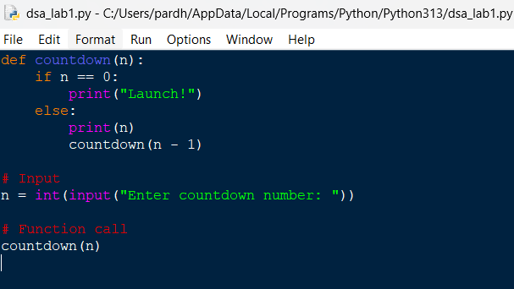
Output:
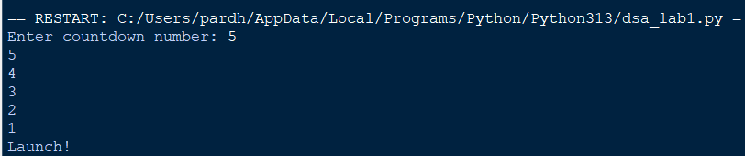

Explanation:
- def defines the countdown() function.
- input() accepts the countdown value from the user.
- int() converts the input into an integer.
- countdown() starts the recursive countdown process.
- if checks the base case (n == 0).
- else executes when the condition is False.
- print(n) displays the current countdown number.
- countdown(n - 1) recursively calls the function with the value decreased by 1.
- print("Launch!") displays the launch message when the countdown reaches 0.
- The program demonstrates the use of functions, recursion, conditional statements, input, and output to perform the countdown.
Error Table:
S.No. | Errors Observed | Rectification
1) | Invalid (non-numeric) input entered by the user. | Enter a valid integer as input.
2) | Missing base case (if n == 0) causing infinite recursion. | Include the base case to stop recursion .l
3) | incorrect indentation leading to an Indentation Error | Maintain proper Python indentation.
4) | Missing colon (:) after def, if, or else. | Add the required colon (:) after statements.
5) | Calling countdown(n) instead of countdown (n - 1), causing infinite recursion. | Decrease the value by 1 in each recursive call using countdown (n - 1).

1B) Aim: Banks calculate the growth of an investment using compound interest. The formula requires calculating powers, which can be implemented recursively. Write a recursive Python program to calculate P^n (power), where P = Principal growth factor, n = number of years.

Program:
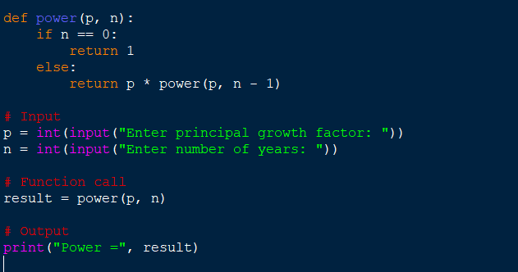
Output:
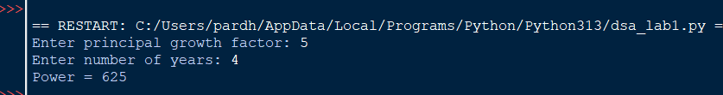

Explanation:
- power() is the recursive function that computes P raised to n.
- The base case is n == 0, which returns 1 (any number to the power 0 is 1).
- The recursive case multiplies p with power(p, n - 1), reducing n by 1 on each call.
- float() allows the principal growth factor to be a decimal value.
- input() collects the values of P and n from the user.
- Each recursive call is stacked until the base case is reached, then the results are multiplied back up the call stack.
- print() displays the final computed value of P^n.
Error Table:
S.No. | Errors Observed | Rectification
1) | Missing base case (n == 0) causing infinite recursion. | Include the base case to stop recursion.
2) | Entering a negative value for n causes the recursion to never reach 0. | Restrict input to non-negative integers or handle negative n separately.
3) | Using int() for P truncates decimal growth factors. | Use float() to accept decimal values for P.
4) | Incorrect indentation leading to an IndentationError. | Maintain proper Python indentation.
5) | Calling power(p, n) instead of power(p, n - 1), causing infinite recursion. | Decrease n by 1 in each recursive call using power(p, n - 1).

1C) Aim: An HR department stores employee IDs in a list. Develop a recursive program to search for a given employee ID. Write a recursive function to search for an employee ID in a list.
Program:
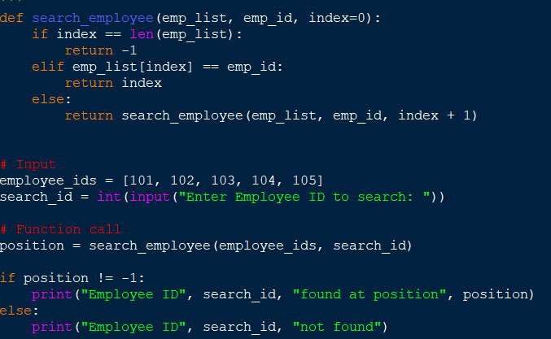
Output:

Explanation:
- search_employee() is the recursive function that searches the list one index at a time.
- The base case index == len(emp_list) means every element was checked and the ID was not found, so it returns -1.
- The second condition checks if the current element matches the employee ID being searched.
- If not matched, the function calls itself with index + 1, moving to the next employee in the list.
- employee_ids is the list of employee IDs stored by the HR department.
- input() and int() collect the employee ID to search for from the user.
- The if-else block reports whether the employee ID was found and at which position.
Error Table:
S.No. | Errors Observed | Rectification
1) | Missing base case (index == len(emp_list)) causing infinite recursion. | Include the base case to stop recursion when the list is exhausted.
2) | Invalid (non-numeric) input entered by the user. | Enter a valid integer as input.
3) | Calling search_employee(emp_list, emp_id, index) without incrementing index, causing infinite recursion. | Increase index by 1 in each recursive call using index + 1.
4) | Incorrect indentation leading to an IndentationError. | Maintain proper Python indentation.
5) | Searching an empty list without handling it, giving a confusing result. | Add a check for an empty list before searching.

1D) Aim:In a logistics company, the number of possible ways to arrange n different parcels is calculated using the factorial formula. Develop a recursive program to calculate the factorial of a given number.
Program:
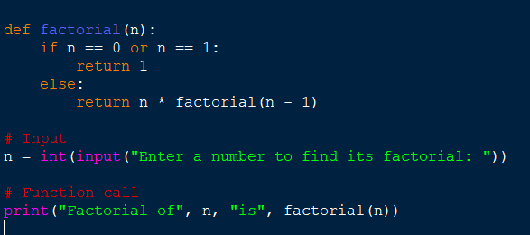
Output:

Explanation:
- factorial() is the recursive function that computes n! (n factorial).
- The base case is n == 0 or n == 1, both of which return 1.
- The recursive case multiplies n with factorial(n - 1), reducing n by 1 on each call.
- input() and int() collect the number whose factorial is to be found.
- Each recursive call is stacked until the base case is reached, then the results are multiplied back up the call stack.
- print() displays the number of possible arrangements (the factorial value).
Error Table:
S.No. | Errors Observed | Rectification
1) | Missing base case (n == 0 or n == 1) causing infinite recursion. | Include the base case to stop recursion.
2) | Entering a negative number, for which factorial is undefined. | Restrict input to non-negative integers.
3) | Invalid (non-numeric) input entered by the user. | Enter a valid integer as input.
4) | Incorrect indentation leading to an IndentationError. | Maintain proper Python indentation.
5) | Calling factorial(n) instead of factorial(n - 1), causing infinite recursion. | Decrease n by 1 in each recursive call using factorial(n - 1).

1E) Aim:Write a recursive Python program to print the first n terms of a Fibonacci series.

Program:
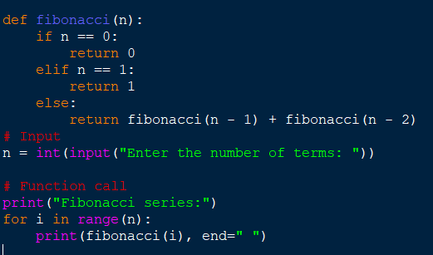

Output:
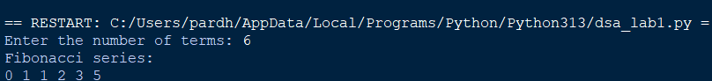

Explanation:
- fibonacci() is the recursive function that returns the nth Fibonacci term.
- The base cases are n == 0 (returns 0) and n == 1 (returns 1).
- The recursive case adds fibonacci(n - 1) and fibonacci(n - 2), following the Fibonacci rule.
- input() and int() collect the number of terms to be printed.
- The for loop calls fibonacci(i) for each index from 0 to n - 1.
- print(..., end=" ") displays each term on the same line, separated by a space.
Error Table:
S.No. | Errors Observed | Rectification
1) | Missing base cases (n == 0 and n == 1) causing infinite recursion. | Include both base cases to stop recursion.
2) | Entering a negative number of terms. | Restrict input to non-negative integers.
3) | Invalid (non-numeric) input entered by the user. | Enter a valid integer as input.
4) | Incorrect indentation leading to an IndentationError. | Maintain proper Python indentation.
5) | Using fibonacci(n - 1) - fibonacci(n - 2) instead of addition, giving wrong terms. | Use addition, fibonacci(n - 1) + fibonacci(n - 2), as per the Fibonacci rule.

WEEK-2

2A) Aim: Write a python program to perform linear search on the given input.
Program:

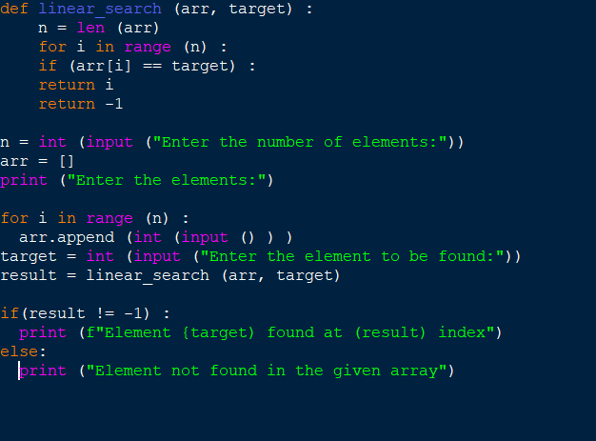
Output:

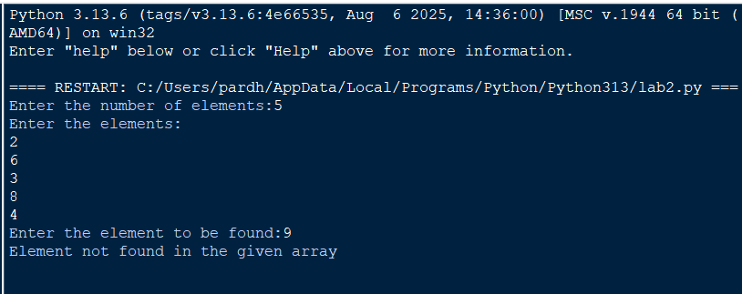

Explanation:
- linear_search(arr, target) sequentially iterates through arr to check each element against target.
- for i in range(n): iterates through array indices from 0 to n-1 sequentially.
- if arr[i] == target: checks for a match and returns index i if found.
- return -1 executes when the target element is absent from the array.
- arr.append(int(input())) converts user input to integers and builds the array.
- if (result != -1): displays the index where the element is found or prints a "not found" message.
Error Table:
S.No. | Errors Observed | Rectification
1) | Invalid (non-numeric) input entered by the user. | Entered a valid integer as input.
2) | Incorrect indentation leading to an Indentation Error | Maintained proper Python indentation.
3) | Missing colon (:) after def, for, if, or else. | Added the required colon (:) after statements.
4) | ValueError when passing non-integer strings to int(input()). | Ensure user input consists of valid integer characters.
5) | IndexError caused by accessing an array index out of bounds. | Ensure loop bounds do not exceed len(arr) - 1.

2B) Aim: Write a python program to perform binary search on the given input.Verify by taking sorted array and unsorted array as input.
Program:
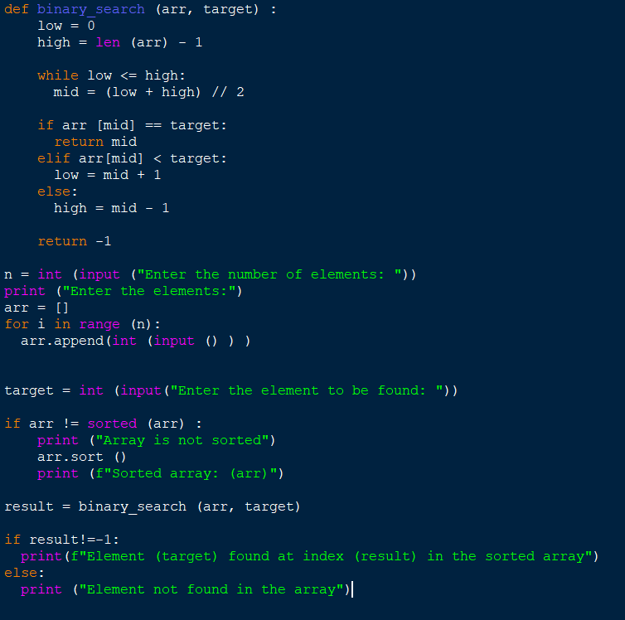
Output:
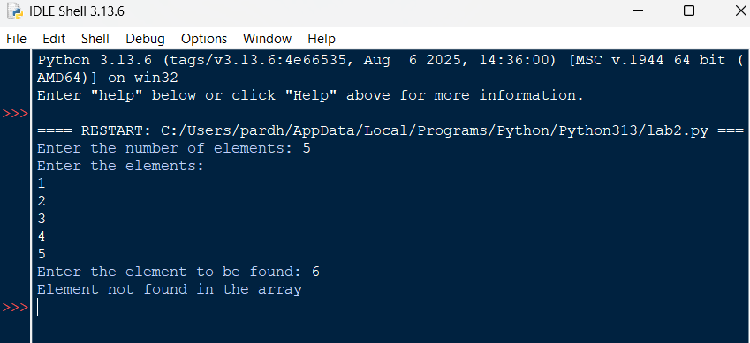
Explanation:
- binary_search(arr, target) uses a divide-and-conquer strategy on a sorted array.
- while low <= high: runs as long as the search boundary contains valid elements.
- mid = (low + high) // 2 computes the middle index using integer division.
- if arr[mid] == target: returns mid if the target is found at the middle index.
- elif arr[mid] < target: updates low = mid + 1, otherwise sets high = mid - 1.
- arr.sort() ensures the input array is sorted before executing binary search.
Error Table:
S.No. | Errors Observed | Rectification
1) | Performing binary search on an unsorted array leading to incorrect results. | Sort the array using arr.sort() before applying binary search.
2) | Using floating-point division / instead of integer division // for calculating mid, causing a TypeError. | Use mid = (low + high) // 2 for integer index calculation.
3) | Incorrect loop condition (low < high instead of low <= high), missing target when low == high. | Change the condition to while low <= high:.
4) | Incorrectly updating pointers like low = mid or high = mid causing an infinite loop. | Use low = mid + 1 and high = mid - 1.
5) | Invalid (non-numeric) input entered by the user. | Enter a valid integer as input.

WEEK-3
3A) Aim: Write a python program to sort an array using selection sort and take the elements as input from user;
Program:
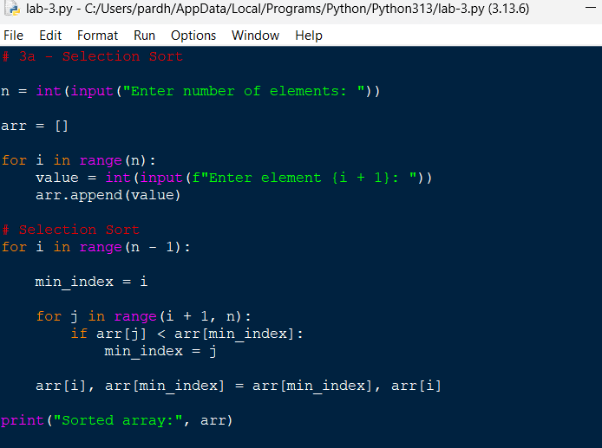
Output:
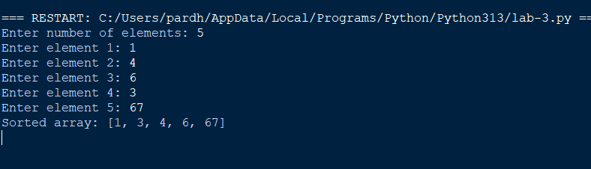

Explanation;
Took the number of elements from the user.
• Created an empty list arr.
• Used a for loop to take each element individually.
• min_index stores the position of the smallest element.
• The inner loop searches for the smallest element in the unsorted portion.
• Swapped the smallest element with the first unsorted element.
• Repeated this until the array was sorted

Error Table:
S.No. | Errors Observed | Rectification
1) | Incorrect initialization of min_index, causing the minimum element to be identified incorrectly. | Initialize min_index = i before searching for the minimum element.
2) | Starting the inner loop from 0, causing already sorted elements to be checked again. | Start the inner loop from i + 1.
3) | Forgetting to update min_index when a smaller element is found. | Use min_index = j inside the if condition.
4) | Incorrect swapping of elements, resulting in an unsorted array. | Use arr[i], arr[min_index] = arr[min_index], arr[i].
5) | Invalid (non-numeric) input entered by the user. | Enter a valid integer for each array element.
6) | Incorrect indentation causing an IndentationError. | Maintain proper indentation inside for loops and if statements.

3B) Aim: Write a python program to sort an array using Insertion sort and take the elements as input from user;
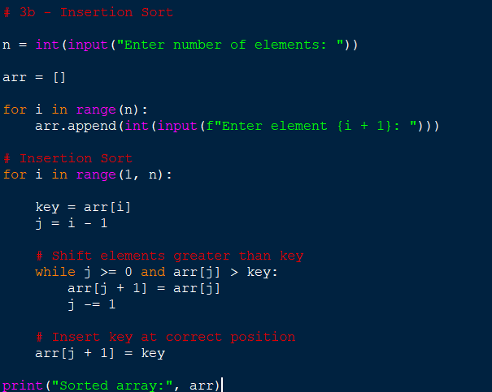
Output:
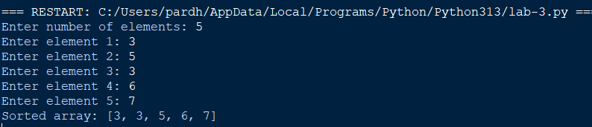

Explanation:
• Took the number of elements from the user.
• Used a loop to input every element.
• Started sorting from index 1.
• Stored the current element in key.
• Compared key with the elements before it.
• Shifted larger elements one position to the right.
• Inserted key into its correct position.
• Repeated until the array was sorted.

Error Table:
S.No. | Errors Observed | Rectification
1) | Starting the outer loop from 0, unnecessarily processing the first element. | Start the loop from 1 because the first element is already considered sorted.
2) | Forgetting to store the current element in key. | Use key = arr[i] before shifting elements.
3) | Forgetting j -= 1, causing the while loop to run indefinitely. | Decrease j by using j -= 1 after shifting an element.
4) | Placing the key at arr[j] instead of arr[j + 1]. | Insert the key using arr[j + 1] = key.
5) | Incorrect condition in the while loop. | Use j >= 0 and arr[j] > key to shift larger elements.

3C) Aim: Write a python program to sort an array using Bubble sort and take the elements as input from user
Program:
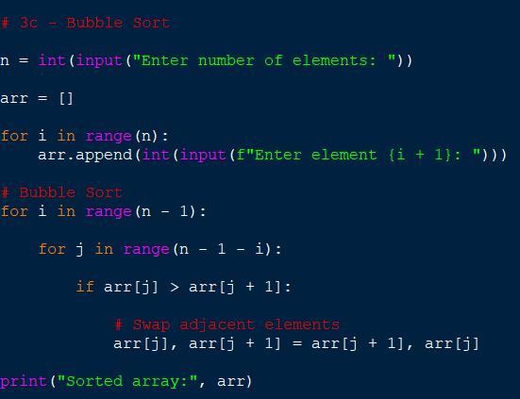
Output:
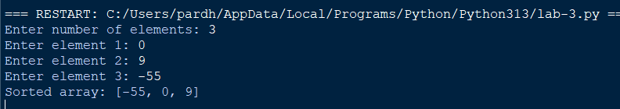

Explanation:
• Took the number of elements.
• Input each element using a loop.
• Compared two adjacent elements.
• If the left element was greater, we swapped them.
• After every pass, the largest remaining element moved to the end.
• Reduced the comparison range after every pass.
• Repeated until the array became sorted.

Error Table:
S.No. | Errors Observed | Rectification
1) | Comparing non-adjacent elements instead of neighboring elements. | Compare arr[j] with arr[j + 1].
2) | Using an incorrect inner loop range. | Use range(n - 1 - i) so that already sorted elements are not checked
3) | Forgetting to swap elements when they are in the wrong order. | Use arr[j], arr[j + 1] = arr[j + 1], arr[j].
4) | Using < instead of > for ascending order. | Use if arr[j] > arr[j + 1] for ascending sorting.
5) | Using an incorrect outer loop range. | Use range(n - 1) to perform the required passes.
6) | Entering non-numeric values as array elements. | Enter valid integer values using int(input()).

3A) Aim: Write a python program to sort an array using Merge sort and take the elements as input from user; 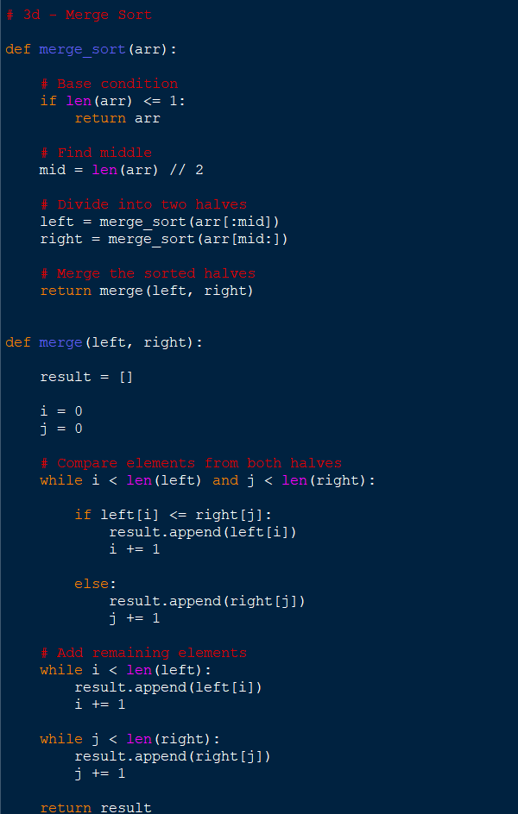

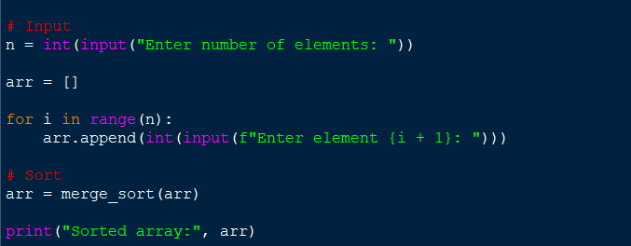

Output:
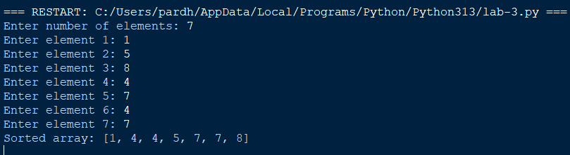

Explanation:
• Took the number of elements from the user.
• Used a loop to input the array.
• Used recursion to divide the array.
• Divided the array into two halves.
• Continued dividing until each part contained one element.
• Used the merge() function to combine the smaller arrays.
• Compared elements from the left and right halves.
• Added the smaller element to result.
• Added remaining elements.
• Returned the sorted array.

S.No. | Errors Observed | Rectification
1) | Missing base case causing infinite recursion. | Include if len(arr) <= 1: return arr to stop recursion.
2) | Incorrect calculation of the middle position. | Use mid = len(arr) // 2 to divide the array correctly.
3) | Incorrectly dividing the array into left and right parts. | Use arr[:mid] for the left half and arr[mid:] for the right half.
4) | Forgetting to increment i or j while merging. | Increment the corresponding index after adding an element to result.
5) | Forgetting to add the remaining elements from either half. | Add the remaining elements using result.extend(left[i:]) and result.extend(right[j:]).
6) | Forgetting to return the merged result. | Use return result at the end of the merge() function.
7) | Incorrect indentation in recursive functions. | Maintain proper indentation for all function statements, loops, and conditions.
3A) Aim: Write a python program to sort an array using Quick sort and take the elements as input from user;
Program:
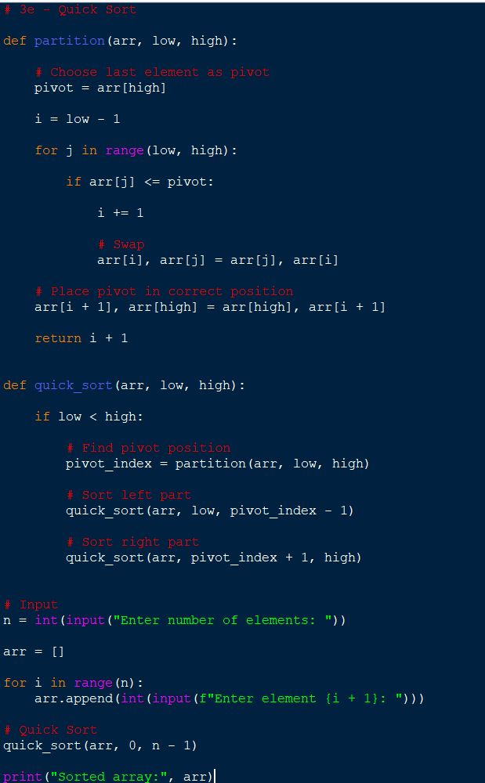
Output:
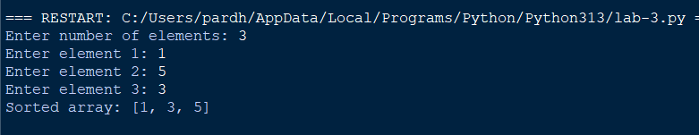

Explanation:
• Took the number of elements.
• Used a loop to input every element.
• Selected the last element as the pivot.
• Compared every element with the pivot.
• Elements smaller than or equal to the pivot were moved to the left.
• Elements greater than the pivot remained on the right.
• Placed the pivot in its correct position.
• Recursively sorted the left and right portions.
• Continued until the entire array was sorted.

S.No. | Errors Observed | Rectification
1) | Missing base condition causing infinite recursion. | Use if low < high: to continue recursion only when elements remain to be sorted.
2) | Incorrectly selecting or accessing the pivot element. | Select the last element using pivot = arr[high].
3) | Forgetting to return the pivot index from the partition function. | Use return i + 1 after placing the pivot.
4) | Incorrect recursive boundaries causing the pivot to be processed again. | Use quick_sort(arr, low, pivot_index - 1) and quick_sort(arr, pivot_index + 1, high).
5) | Incorrect initial function call. | Call quick_sort(arr, 0, n - 1) to sort the complete array.
6) | Incorrect partition condition resulting in improper ordering. | Use if arr[j] <= pivot for ascending order.
7) | Forgetting to swap the pivot into its correct position. | Use arr[i + 1], arr[high] = arr[high], arr[i + 1].
8) | Incorrect indentation causing an IndentationError. | Maintain proper Python indentation inside functions, loops, and conditions.

WEEK-4
Aim: Write a menu-driven Python program to implement a Circular Linked List using classes Node and LinkedList.
The program should support the following operations:
- Create a linked list with n nodes.
- Insert a node at the beginning.
- Insert a node at the end.
- Insert a node at a specific index.
- Delete a node from a specific index.
- Delete the first node.
- Delete the last node.
- Count the number of nodes in the linked list.
- Display/traverse the linked list.
- Exit the program.
Program:
class Node:
def __init__(self, data):
self.data = data
self.next = None

class LinkedList:
def __init__(self):
self.head = None

# 1. Create a linked list
def create(self):
n = int(input("Enter number of nodes: "))

for i in range(n):
data = int(input("Enter value: "))
new_node = Node(data)

if self.head is None:
self.head = new_node
else:
temp = self.head
while temp.next is not None:
temp = temp.next
temp.next = new_node

# 2. Insert at beginning
def insert_beginning(self):
data = int(input("Enter value: "))
new_node = Node(data)

new_node.next = self.head
self.head = new_node

# 3. Insert at end
def insert_end(self):
data = int(input("Enter value: "))
new_node = Node(data)

if self.head is None:
self.head = new_node
return

temp = self.head
while temp.next is not None:
temp = temp.next

temp.next = new_node

# 4. Insert at a specific index
def insert_index(self):
data = int(input("Enter value: "))
index = int(input("Enter index: "))

new_node = Node(data)

if index == 0:
new_node.next = self.head
self.head = new_node
return

temp = self.head
prev = None
count = 0

while temp is not None and count < index:
prev = temp
temp = temp.next
count += 1

if count != index:
print("Invalid index")
return

prev.next = new_node
new_node.next = temp

# 5. Delete at a specific index
def delete_index(self):
index = int(input("Enter index to delete: "))

if self.head is None:
print("List is empty")
return

if index == 0:
self.head = self.head.next
return

temp = self.head
prev = None
count = 0

while temp is not None and count < index:
prev = temp
temp = temp.next
count += 1

if temp is None:
print("Invalid index")
return

prev.next = temp.next

# 6. Delete first node
def delete_first(self):
if self.head is None:
print("List is empty")
return

self.head = self.head.next

# 7. Delete last node
def delete_last(self):
if self.head is None:
print("List is empty")
return

if self.head.next is None:
self.head = None
return

temp = self.head

while temp.next.next is not None:
temp = temp.next

temp.next = None

# 8. Count number of nodes
def count_nodes(self):
count = 0
temp = self.head

while temp is not None:
count += 1
temp = temp.next

print("Number of nodes:", count)

# 9. Display / Traverse
def display(self):
if self.head is None:
print("List is empty")
return

temp = self.head

while temp is not None:
print(temp.data, end=" -> ")
temp = temp.next

print("None")

# Main program
linked_list = LinkedList()

while True:
print("\n----- SINGLY LINKED LIST -----")
print("1. Create a linked list")
print("2. Insert at beginning")
print("3. Insert at end")
print("4. Insert at a specific index")
print("5. Delete at a specific index")
print("6. Delete first node")
print("7. Delete last node")
print("8. Count number of nodes")
print("9. Display / Traverse")
print("10. Exit")

choice = int(input("Enter your choice: "))

if choice == 1:
linked_list.create()

elif choice == 2:
linked_list.insert_beginning()

elif choice == 3:
linked_list.insert_end()

elif choice == 4:
linked_list.insert_index()

elif choice == 5:
linked_list.delete_index()

elif choice == 6:
linked_list.delete_first()

elif choice == 7:
linked_list.delete_last()

elif choice == 8:
linked_list.count_nodes()

elif choice == 9:
linked_list.display()

elif choice == 10:
print("Exiting...")
break

else:
print("Invalid choice")

Output:
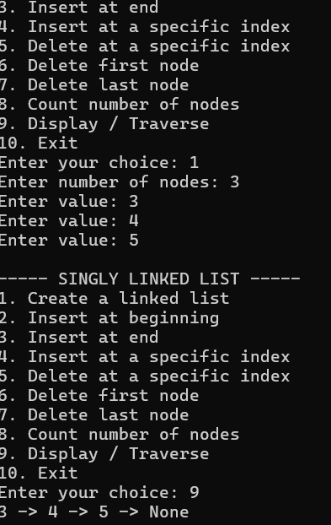
Singly Linked List — Code Explanation
- Node class creates each node with two parts: data and next.
- LinkedList class maintains the linked list using a head pointer.
- create() creates n nodes and connects each new node to the previous node.
- insert_beginning() creates a node and places it before the current head.
- insert_end() traverses to the last node and attaches the new node there.
- insert_index() traverses to the required position and inserts the new node between two nodes.
- delete_index() removes the node at the given index by changing the previous node's next pointer.
- delete_first() and delete_last() remove the first and last nodes respectively.
- count_nodes() traverses the list and counts every node until None is reached.
- display() traverses from head to None and prints all node values.

Errors Encountered:

S.No | Error Observed | Rectification
1 | self.head is not initialized. | Add self.head = None in the LinkedList constructor.
2 | insert_end() does not handle an empty list. | If self.head is None, set self.head = new_node and return.
3 | insert_index() does not handle index 0. | Handle index == 0 separately as insertion at the beginning.
4 | delete_last() fails for a single-node list. | If self.head.next is None, set self.head = None.
5 | display() does not move temp to the next node. | Add temp = temp.next inside the traversal loop.

WEEK-5
Aim: Write a menu-driven Python program to implement a Circular Linked List using classes Node and LinkedList.
The program should support the following operations:
- Create a linked list with n nodes.
- Insert a node at the beginning.
- Insert a node at the end.
- Insert a node at a specific index.
- Delete a node from a specific index.
- Delete the first node.
- Delete the last node.
- Count the number of nodes in the linked list.
- Display/traverse the linked list.
- Exit the program.
Program:
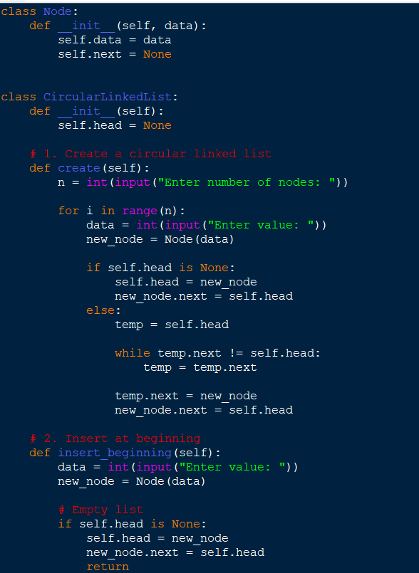

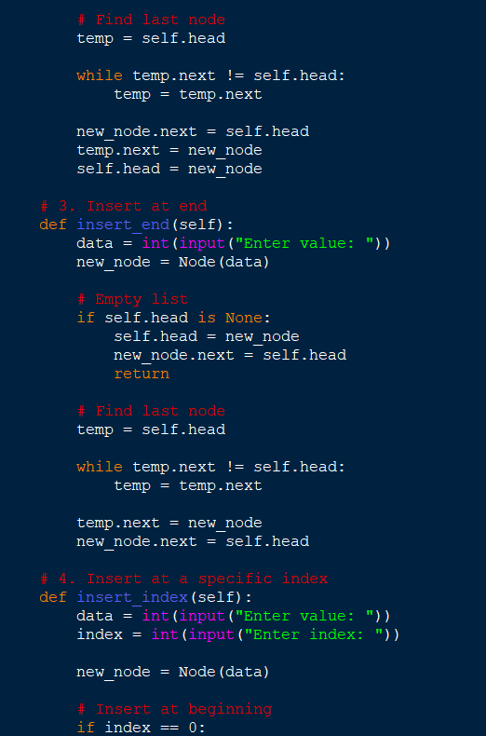
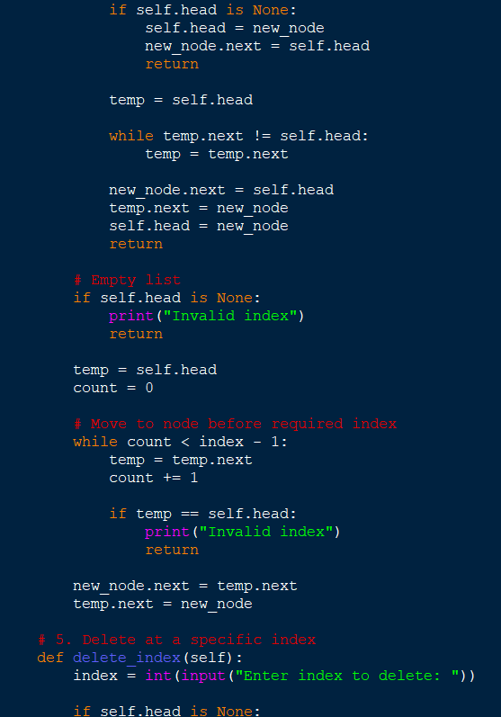
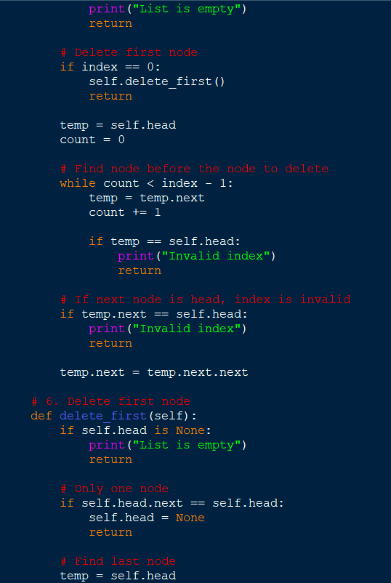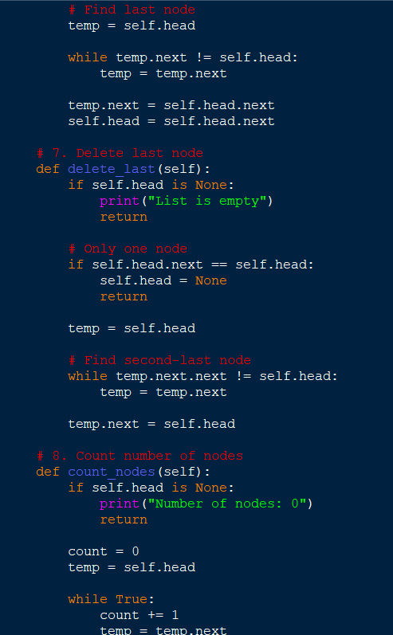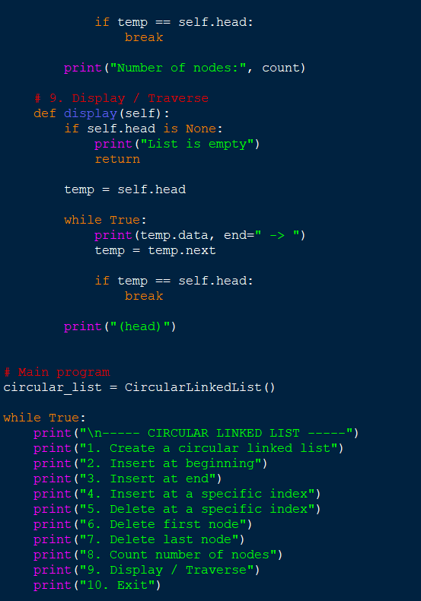
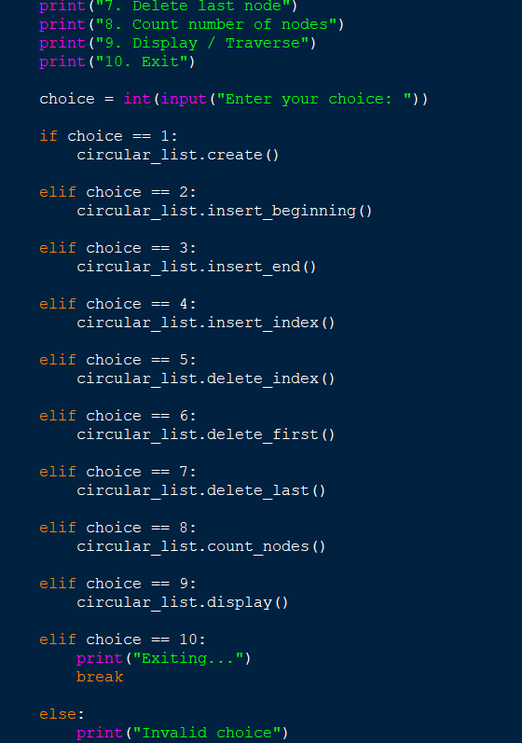
Output:
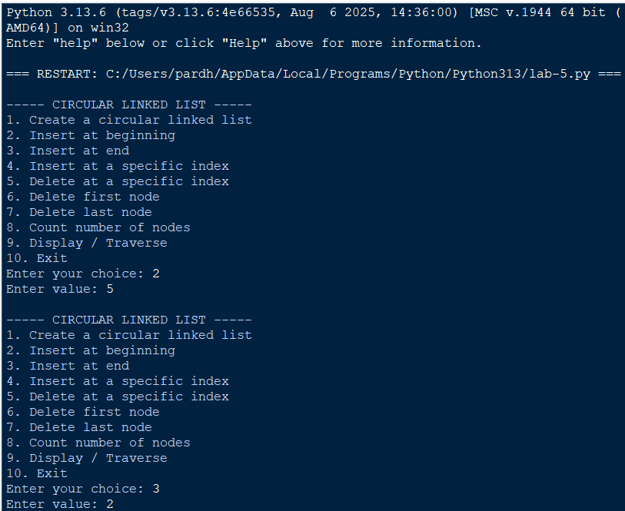

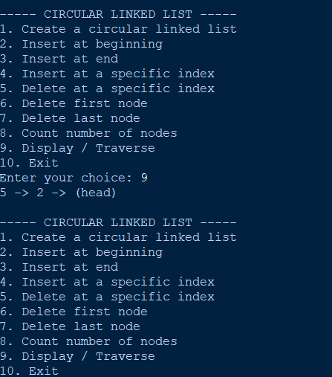

Circular Linked List — Code Explanation
- Node class creates each node with data and a next pointer.
- CircularLinkedList class maintains the list using a head pointer.
- In a circular list, the last node always points back to head, instead of None.
- create() creates nodes and connects the final node back to head.
- insert_beginning() adds a node before head and updates the last node to point to the new head.
- insert_end() finds the last node, adds the new node, and makes it point to head.
- insert_index() traverses to the required position and connects the new node into the circular chain.
- delete_index(), delete_first(), and delete_last() remove nodes while maintaining the circular connection.
- count_nodes() counts nodes until traversal reaches head again.
- display() prints nodes until it reaches head again, preventing an infinite loop.
Errors Encountered:

S.No | Error Observed | Rectification
1 | First node does not point back to head. | Set new_node.next = self.head when creating the first node.
2 | while temp is not None is used to find the last node. | Use while temp.next != self.head:.
3 | Circular traversal causes an infinite loop. | Stop traversal when temp == self.head again.
4 | delete_first() does not update the last node. | Set the last node's next to the new head.
5 | Single-node circular list is not handled during deletion. | Check self.head.next == self.head and set self.head = None.

